Table of Contents
User 1
Login and Register 1
Browsing the vehicle 2
Book a vehicle 4
View “My Bookings” 5
View the booking details 5
Cancel the booking 6
Checkout Vehicle 7
Overdue Rentals 9
Logout 11
Admin 12
Admin login 12
Add new vehicle 12
Edit vehicle 15
Delete vehicle 16
Mark vehicle under maintenance 17
Mark vehicle available 18
View maintenance history 19
View all customer reservations. 20
Cancel a confirmed booking on behalf of a customer 23
Inspect a returned vehicle 23
Reservation status explanations 26

User

Login and Register
How to login?
Click “Create an account”
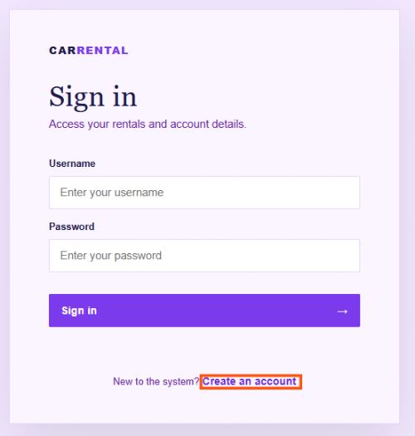
Enter username, password, full name and phone number.
Then click the “Create account”
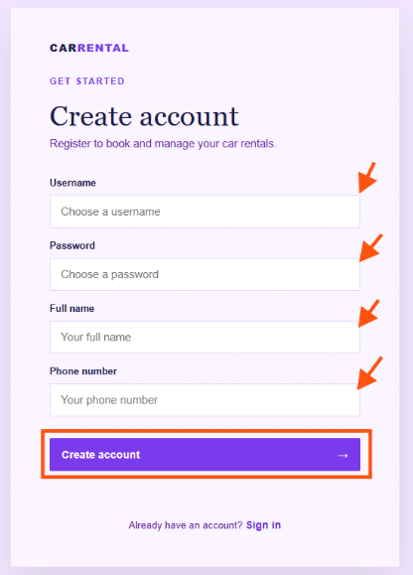
Enter the valid username and password then click “Sign in”
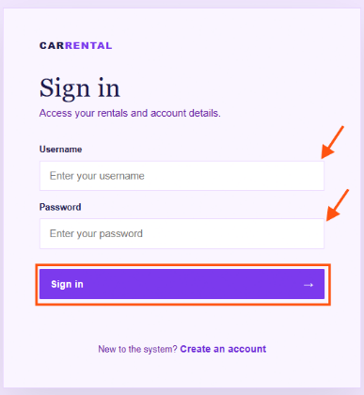

Browsing the vehicle
Login to the system with valid username and password
Three categories of the vehicle displayed in home page
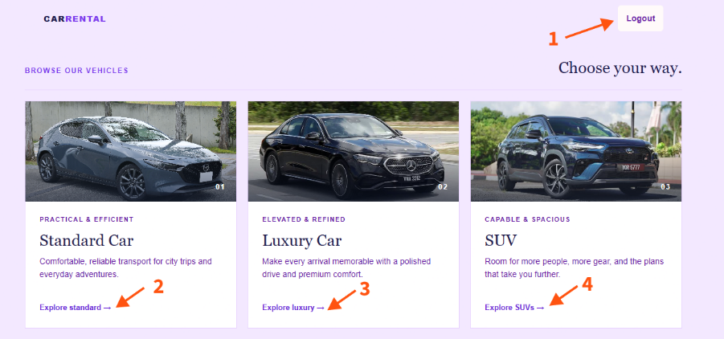
1. Logout button: Logs out of the system and ends your session.
2. Explore standard: Displays available standard vehicle models.
3. Explore luxury: Displays available luxury vehicle models.
4. Explore SUVs: Displays available SUV models.

After clicking on one of the categories.
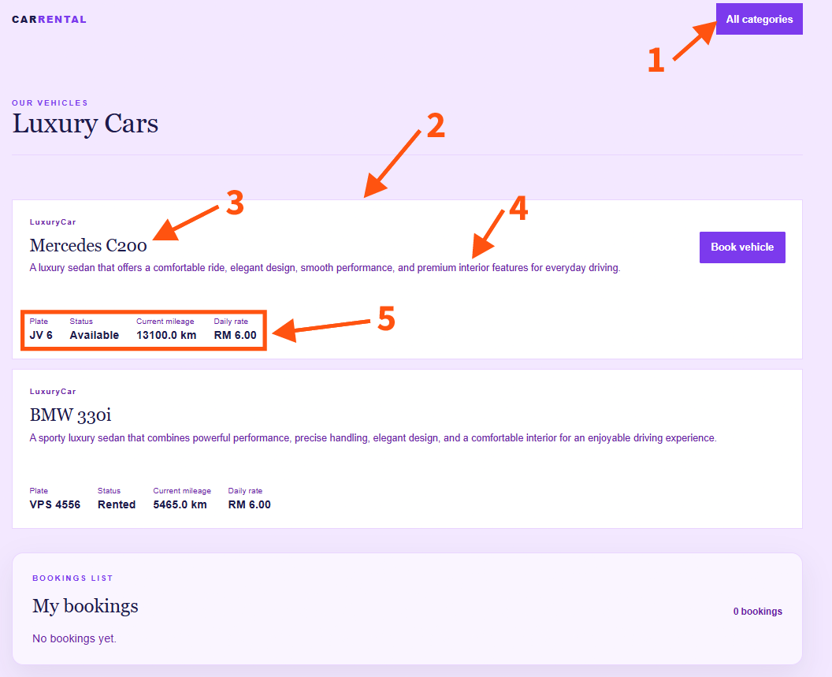
1. All categories: Returns you to the main categories list and continue browsing other vehicles.
2. Available vehicle list: Displays all vehicles currently available for rental, along with key summary details.
3. Vehicle brand and model
4. Vehicle description
5. Vehicle details: Shows comprehensive information for a selected vehicle, including license plate number, current status, mileage, and daily rental rate.

Book a vehicle
Find the vehicle that you interesting.
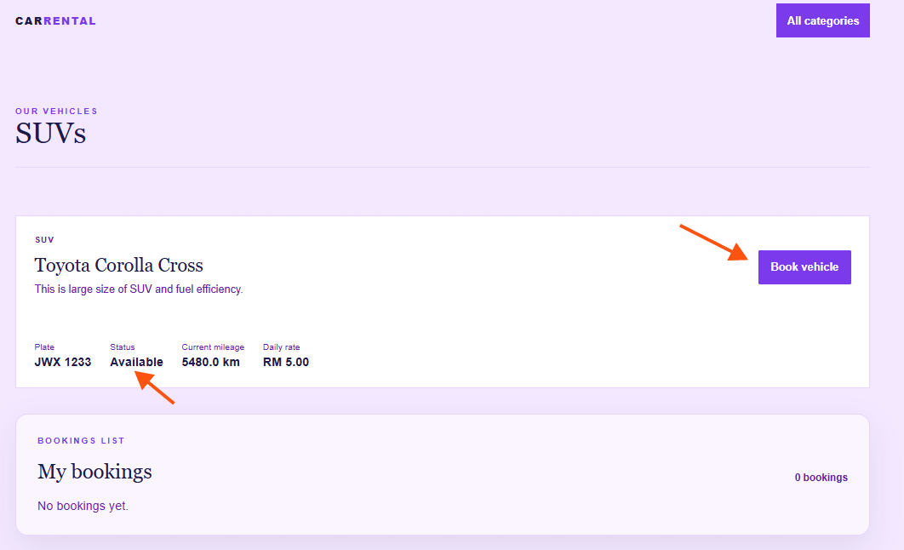
You can book the vehicle if the vehicle is “Available”
Click the “Book vehicle” button
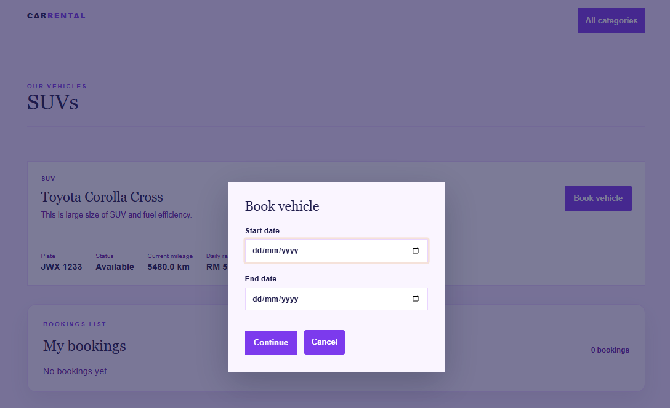
Select the start and end dates for your vehicle rental and click continue.

View “My Bookings”
Under the vehicle lists, your booked vehicle will display in the “My bookings” block.
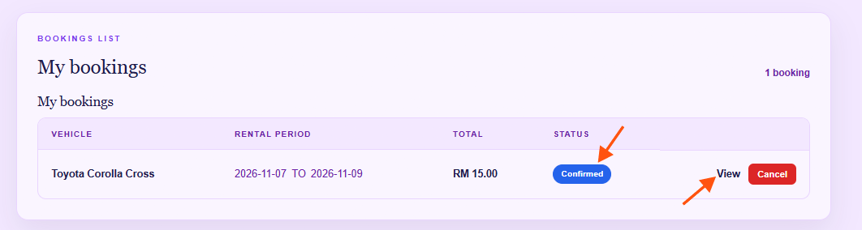
Once booked, the status updates to Confirmed. On the rental start date, the status automatically changes to Active.

View the booking details
Click View to see the booking details.
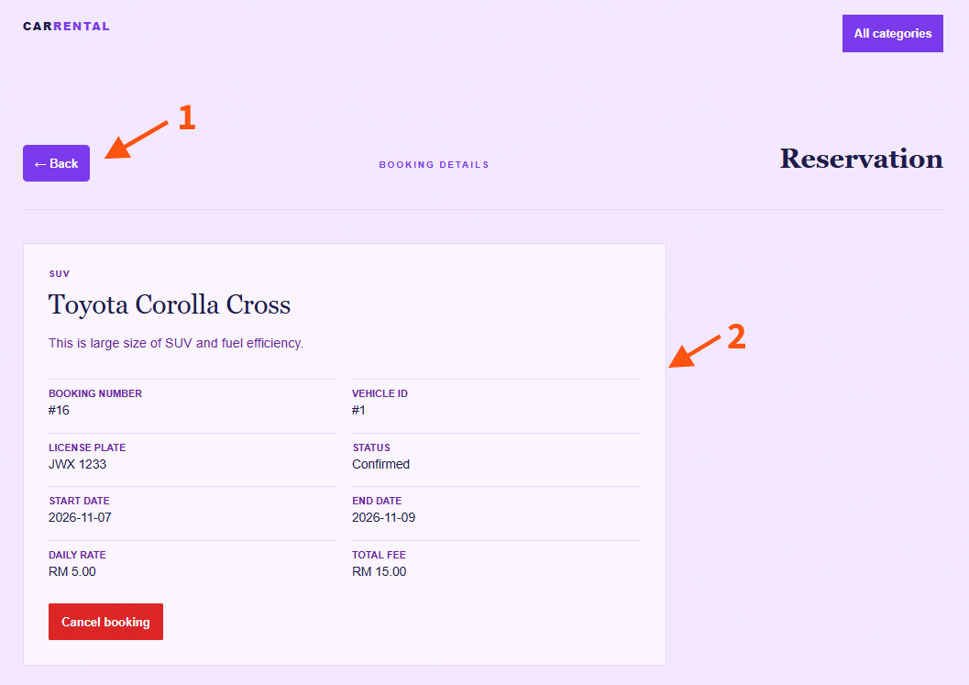
1. Back: Click Back to return to the previous page.
2. Booking Details: View comprehensive reservation information, including the license plate, booking duration, and total fee.

Cancel the booking
Only bookings with a Confirmed status can be cancelled. To cancel a reservation, click Cancel in the booking list or on the booking details page.
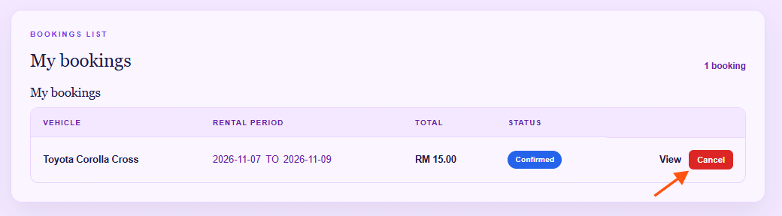
Cancel the booking in booking details page.
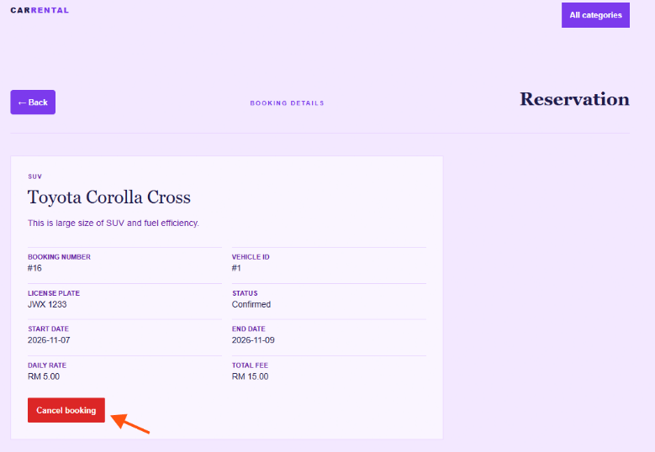

Checkout Vehicle
Locate the reservation you want to check out.
Click Check Out to perform the check out.
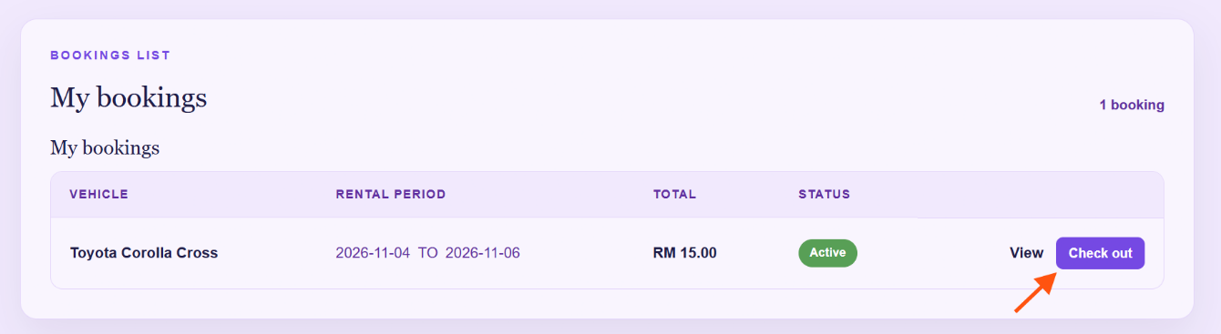
Enter the latest mileage of the vehicle and click “Confirm checkout”
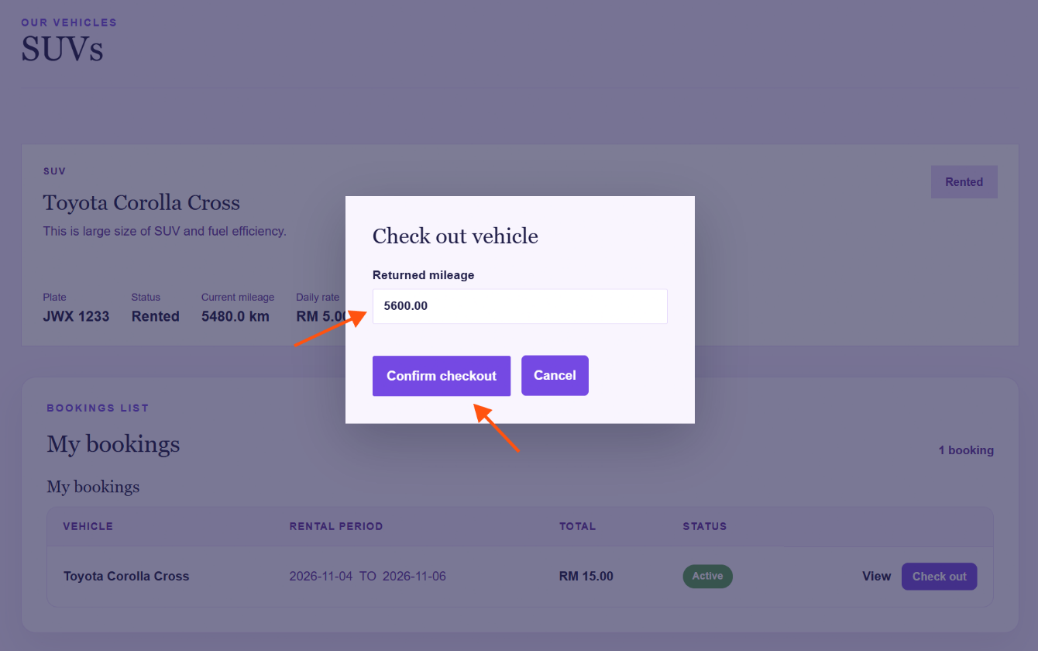

After submitting, your booking status will change to Pending Inspection. The return process will be completed once an administrator inspects and approves the returned vehicle.
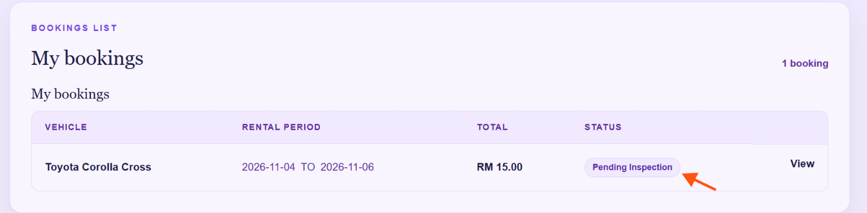

After the admin approves the inspection, you will need to pay any incurred damage fees.
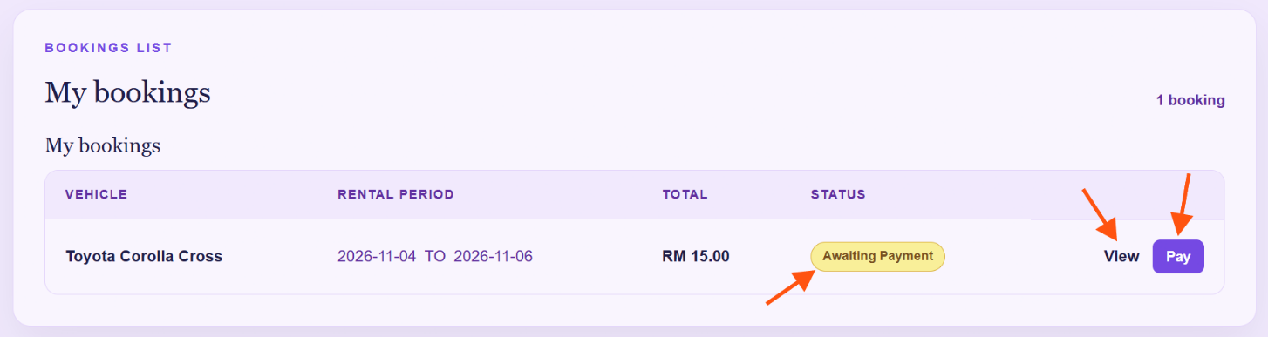
If damage fees are incurred, your status will change to Awaiting Payment. You can click View to inspect the fee details or click Pay to settle the damage fee directly.
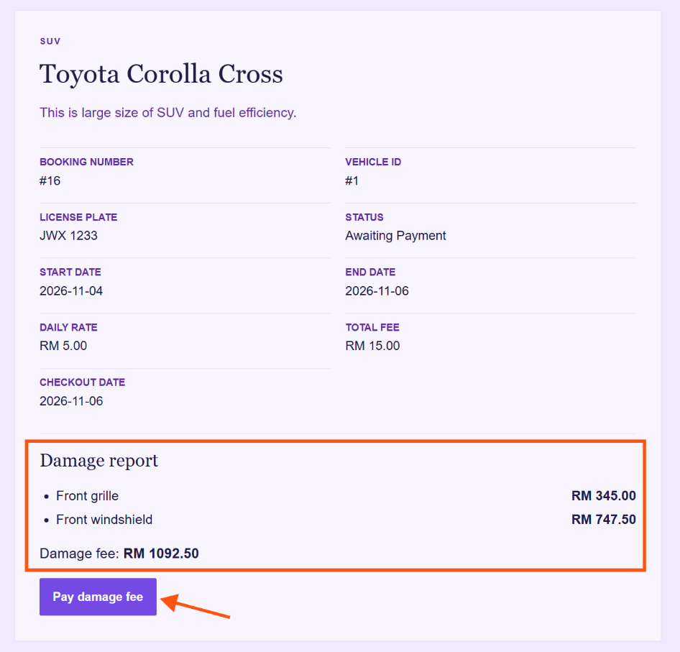
Review the damage report, then click Pay Damage Fee to settle the charge and complete the vehicle return process.

Overdue Rentals
If a vehicle is returned past its scheduled end date, the booking status changes to Overdue, and the calculated overdue fee will be displayed in your reservation list.
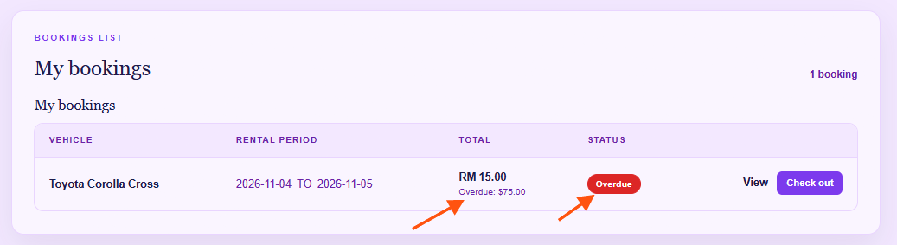
After you click inside the details page via “View” button
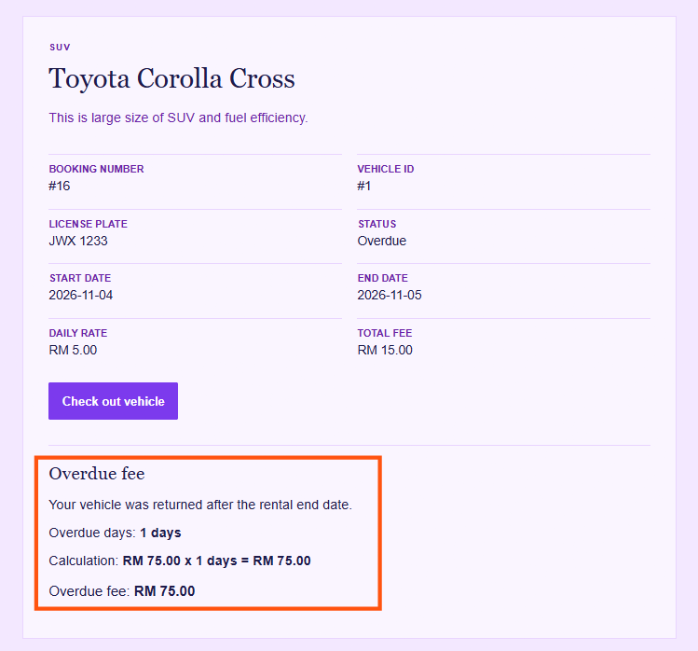
The system automatically displays the breakdown of your calculated overdue fees based on fixed daily rates for each vehicle category:
- Standard Car: RM 50 / day
- SUV: RM 75 / day
- Luxury Car: RM 100 / day

To complete checkout for an overdue rental, enter the vehicle's latest odometer reading under Returned Mileage, await administrative inspection, and settle the calculated Overdue Fee along with any applicable Damage Fee
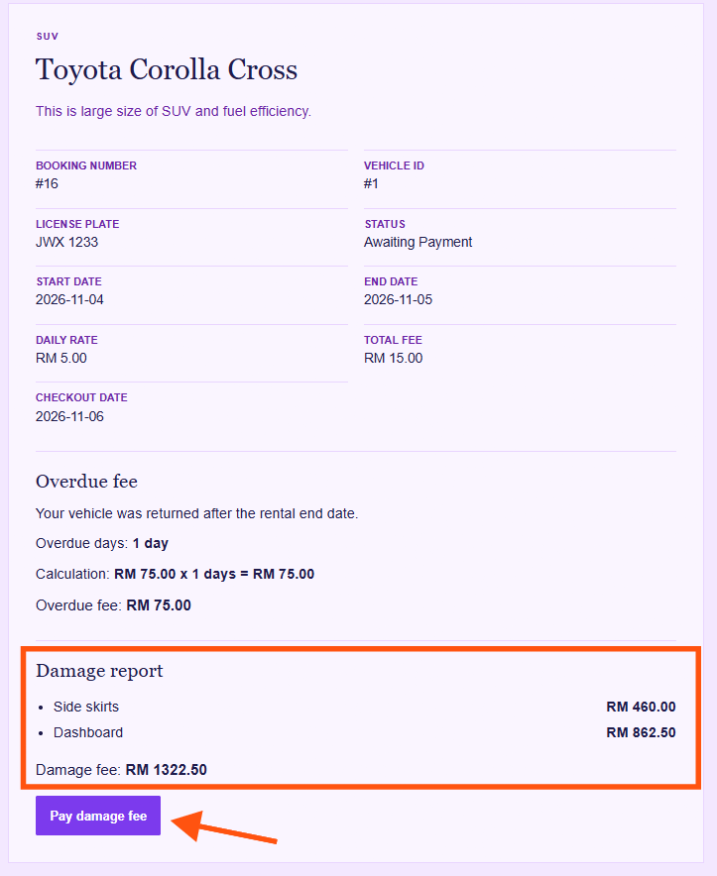

Logout
Click Logout on the home page to log out of the system.
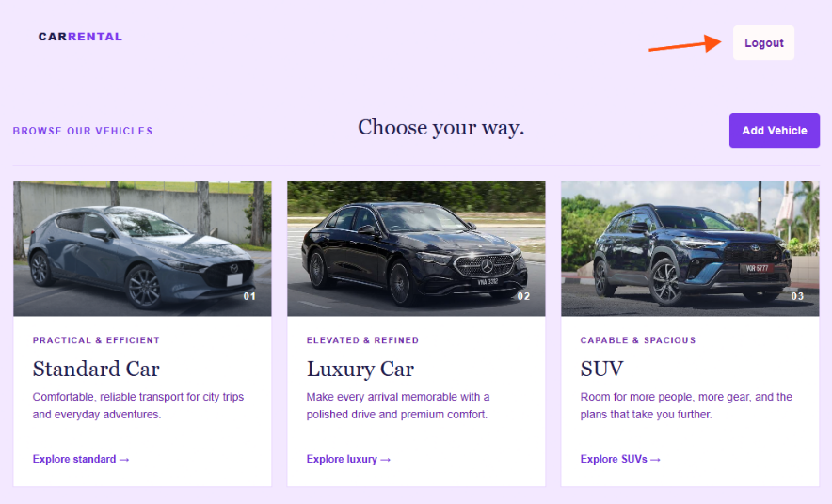

Admin

Admin login
Username: admin
Password: carrentadmin430

Add new vehicle
Click Add Vehicle to register a new vehicle in the system.
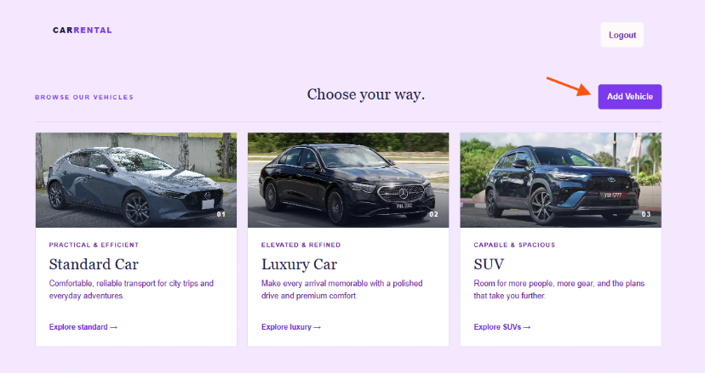
Enter required fields for registering a new vehicle
License plate: VCB 2689
Brand: Proton
Model: X90
Description: A modern 7-seater SUV featuring a spacious interior, turbocharged engine, advanced safety features and comfortable seating. Suitable for family trips and long-distance journeys.
Category: SUV
Status: Available
Mileage: 1273
Daily rate (RM): 472
After filling in all required fields, click Save Vehicle to store the new vehicle in the system.

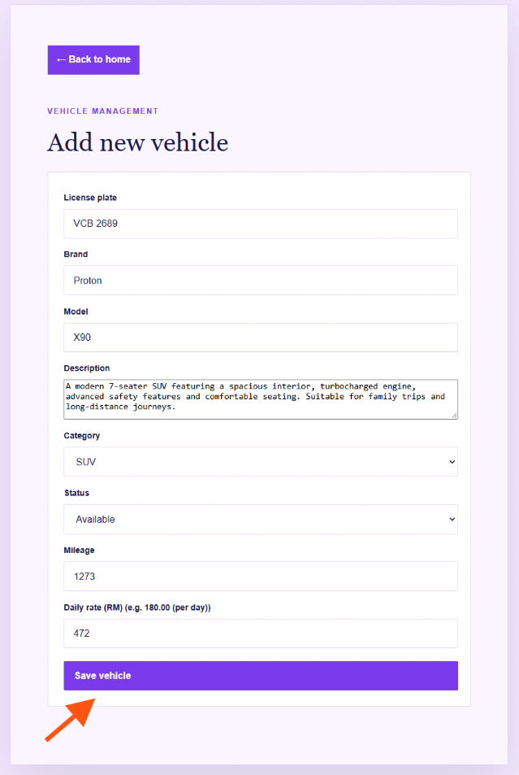

Once the vehicle is saved successfully, a confirmation message will appear. Click Back to Home to return to the main page.
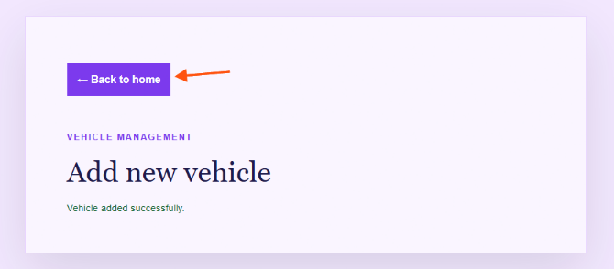
Open the vehicle category corresponding to your newly added vehicle.
Verify that the new vehicle entry appears in the available list.
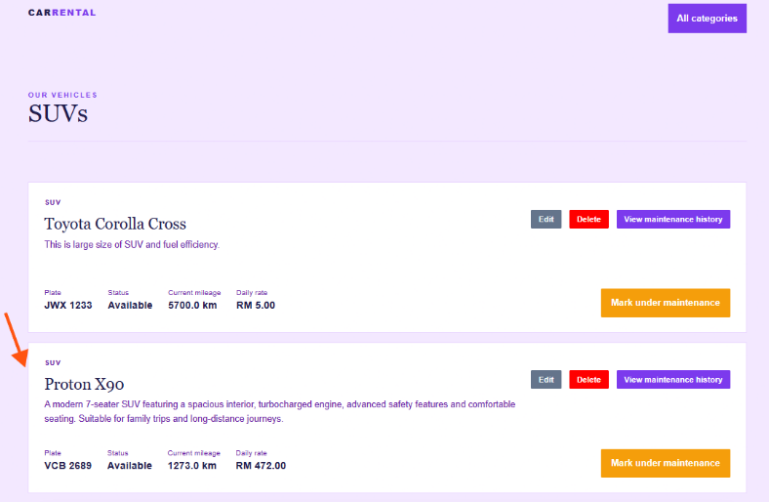

Luxury vehicles included additional charges, including a Security Deposit and an Insurance Rate, to provide extra coverage and protection during the rental.
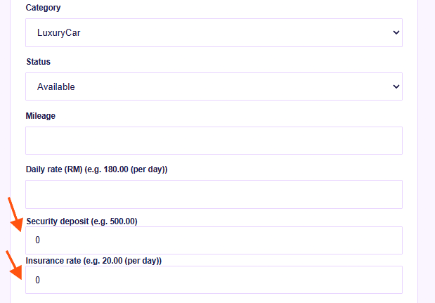

Edit vehicle
Select the vehicle you wish to modify and click Edit.
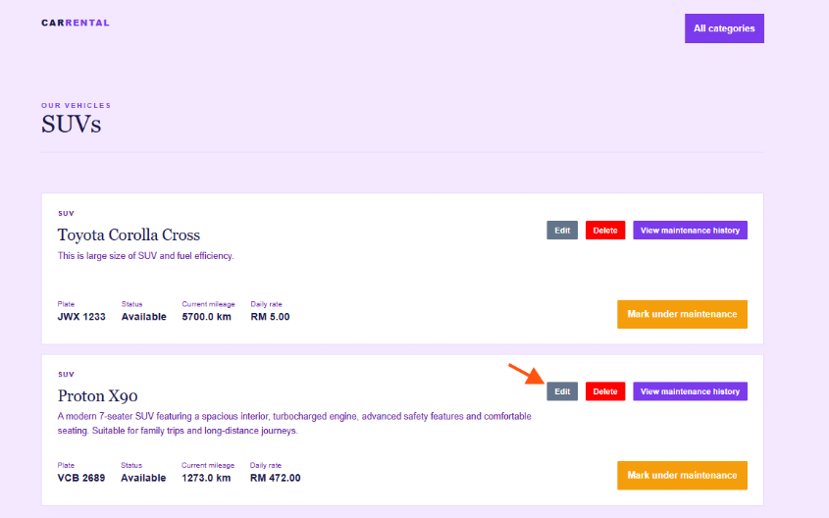

The system will display a pop-up form allowing you to edit the vehicle's details.
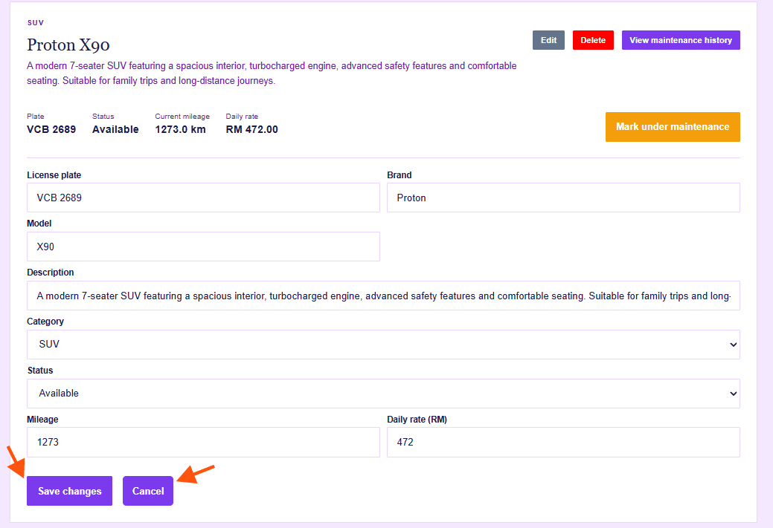
Click Save Changes to apply your updates, or click Cancel to discard them and close the form.

Delete vehicle
Select the vehicle you wish to remove and click Delete.
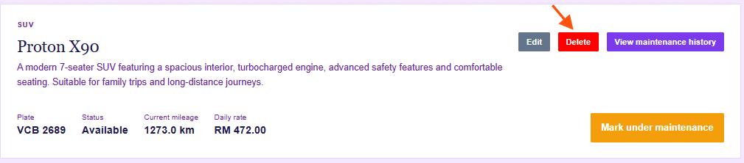
Click OK on the confirmation prompt to permanently remove the vehicle from the system.
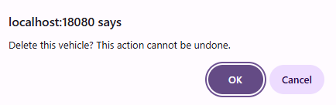

Mark vehicle under maintenance
Select the vehicle you wish to mark and click Mark under maintenance.
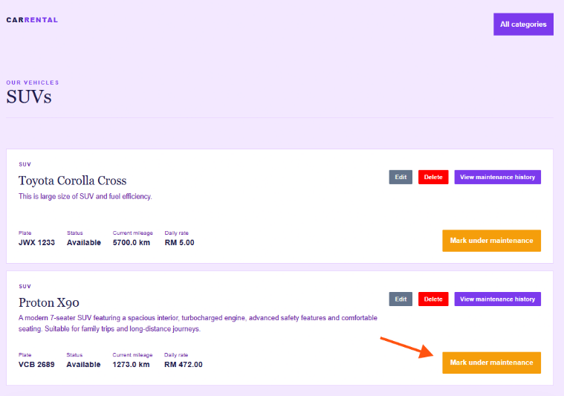
Enter the relevant maintenance details in the Maintenance Notes field before proceeding.
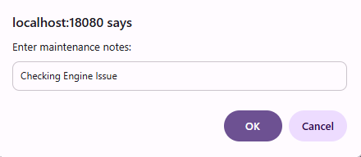
The vehicle status will update to Under Maintenance, preventing users from renting or reserving it.
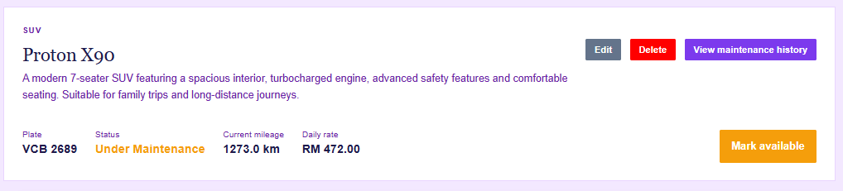

Mark vehicle available
Locate the vehicle listed as Under Maintenance and click Mark Available to make it eligible for rent again.
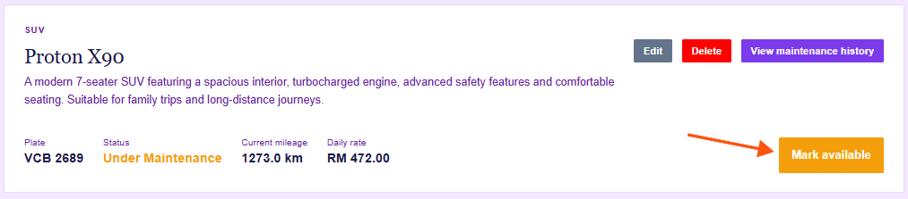
In the pop-up prompt, enter optional details under Enter maintenance completion notes (optional)
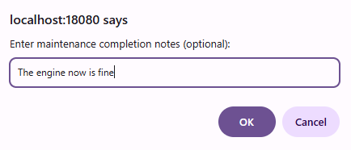
The vehicle status will update back to Available, making it ready for customer rentals.
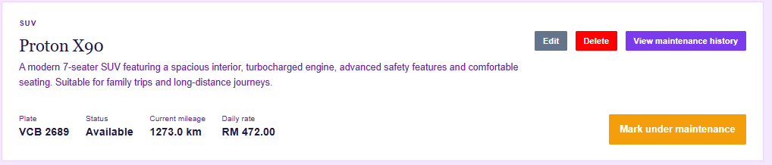

View maintenance history
Locate the target vehicle and click View Maintenance History to review its past service records.
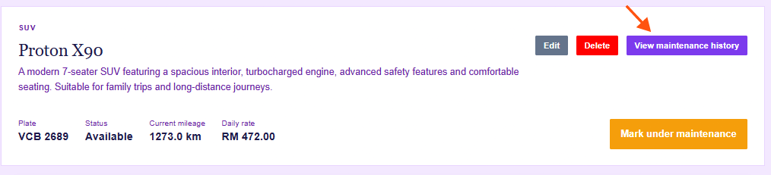
The maintenance history is displayed in a structured table containing Start Date, End Date, Started By, Notes, and Completion Notes.
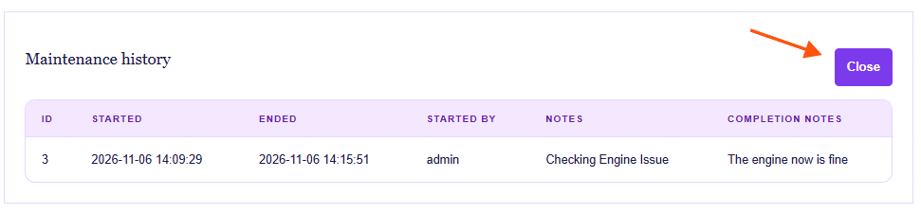
Click Close to close the table once you have completed your review.

View all customer reservations.
Click into one of the vehicle categories.
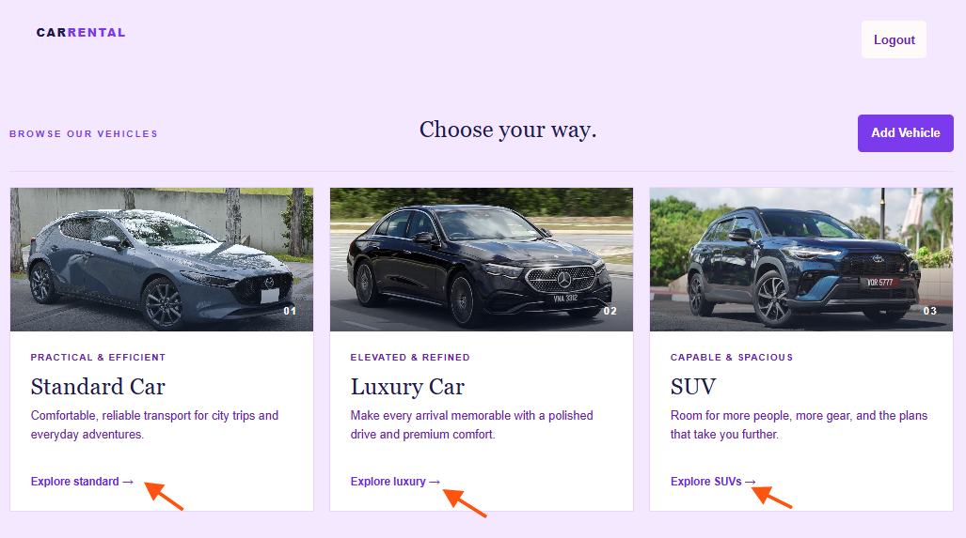

Scroll down to find the reservation table
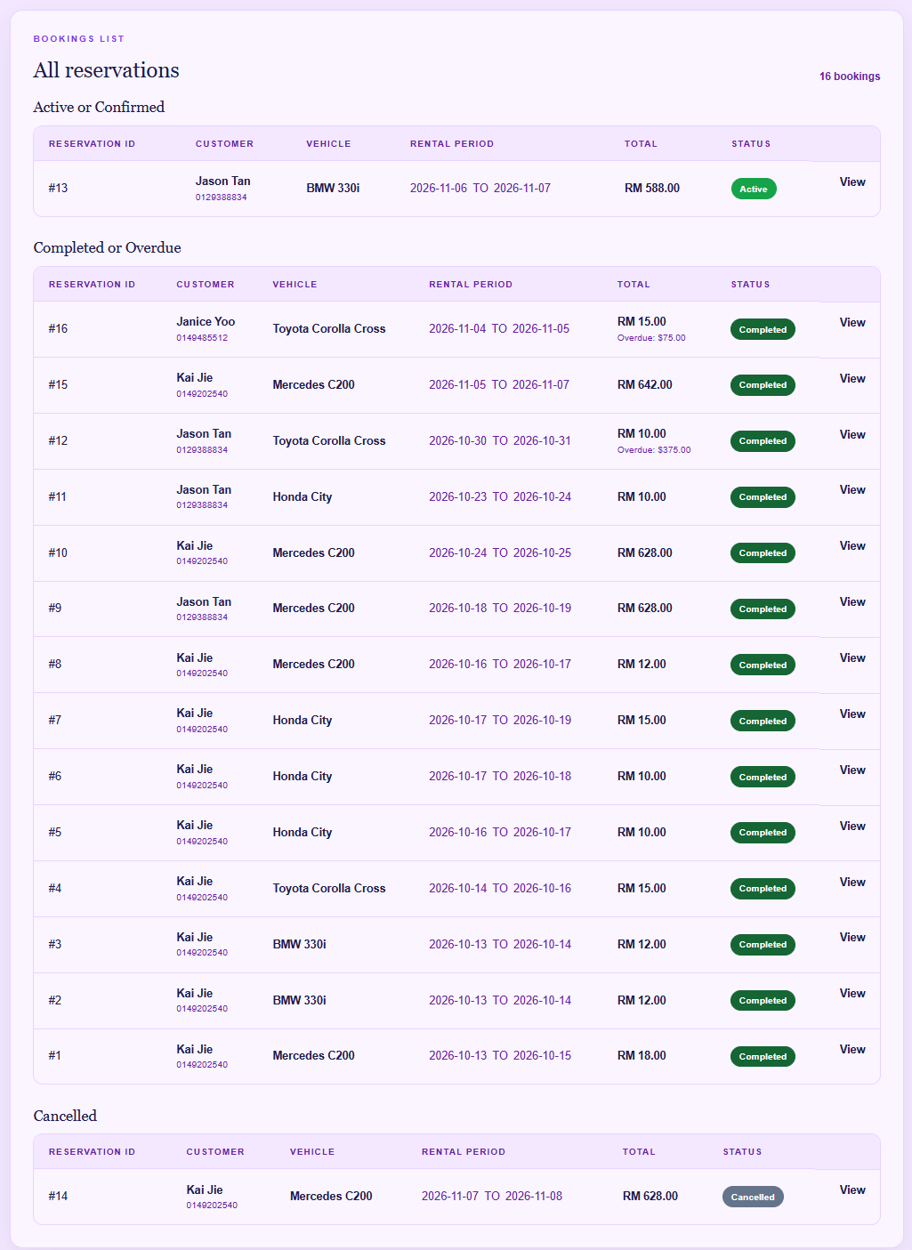
Reservations are categorized into three sections: Active or Confirmed, Completed or Overdue, and Cancelled. The summary table displays the customer name, phone number, rented vehicle, rental period, total rental fees, and status. Click View to open and inspect the details of a specific reservation.

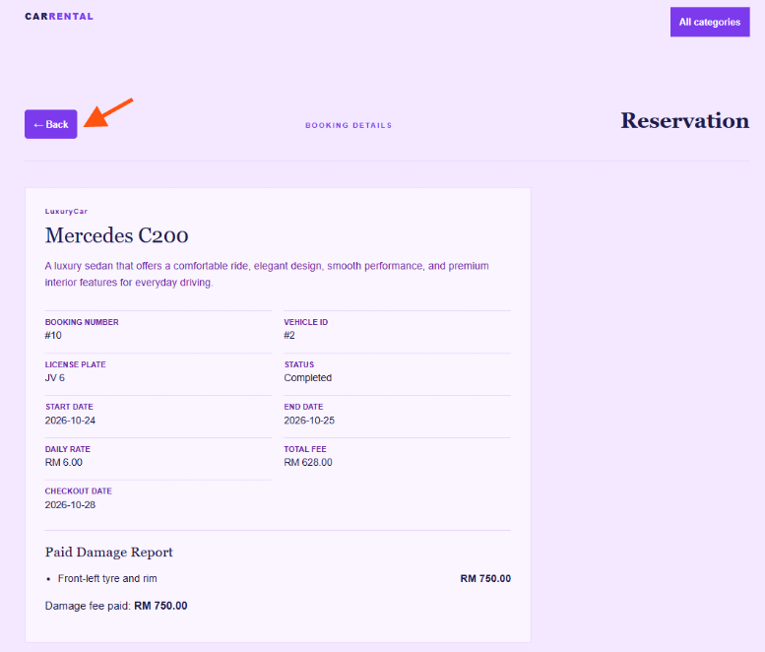
Click Back to return to the reservation table view.

Cancel a confirmed booking on behalf of a customer
Locate the reservation you wish to cancel on behalf of a customer, ensuring its status is Confirmed (not yet Active).
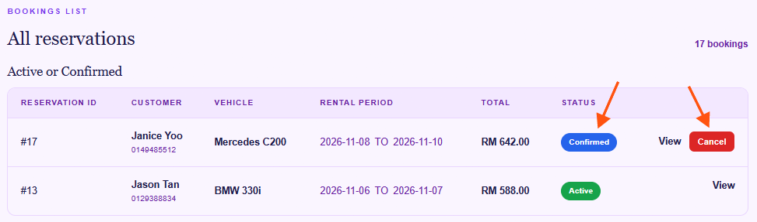
Click Cancel on the reservation entry. The system will update its status to Cancelled.
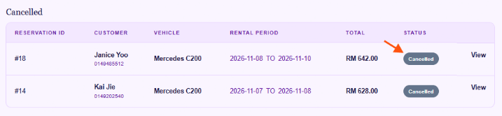

Inspect a returned vehicle
When a customer returns a vehicle, locate the reservation under the Pending Inspection section.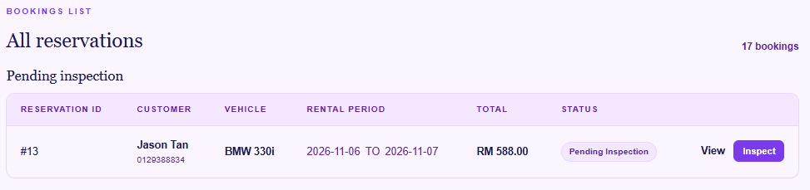
Click Inspect to begin evaluating the vehicle for damage and verifying its conditions.
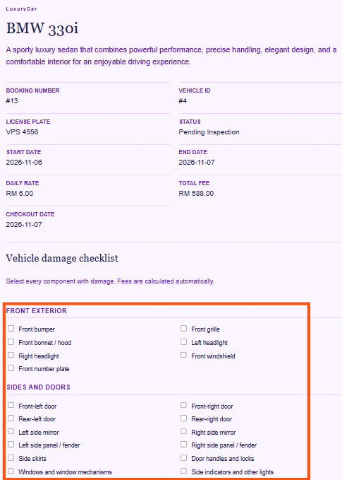
Complete the damage checklist according to the vehicle's current condition, then click Submit Damage Report to submit the form.

The reservation will transition to Awaiting Payment status until the customer settles the required fees.
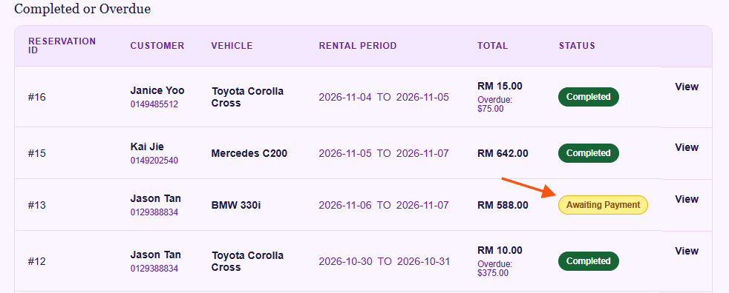
Click View to inspect the detailed damage report associated with the reservation.
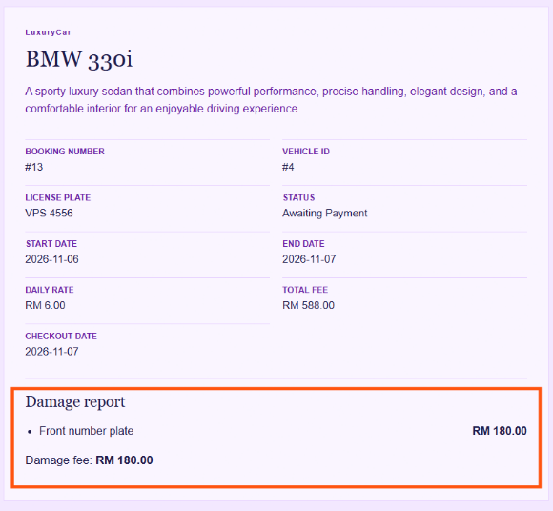

Reservation status explanations
Confirmed — booking has been created.
Active — rental period has started.
Overdue — vehicle was not returned by the end date.
Pending Inspection — vehicle has been returned and awaits administrator inspection.
Awaiting Payment — damage fees must be paid.
Completed — rental process is finished.
Cancelled — booking was cancelled.
Under Maintenance — vehicle cannot be booked.
Available — vehicle can be booked.

